JSON Object()

• **Enclose Objects in {}:**  
JSON objects are wrapped in curly braces.({} এর ভিতরে থাকবে।)

• **Key-Value Pairs (ডাটা {} এর ভিতরে key-value pair এ থাকবে।)**

* Keys must always be **strings** (in double quotes).(key অবশ্যই string এ থাকবে।)
* Values can be a string, number, boolean, null, another object, or an array.

• **Use Double Quotes:** **.(string অবশ্যই “ ” এ থাকবে।)**  
Strings and keys must be enclosed in **double quotes**

• **Commas Separate Pairs:**  
Use commas between key-value pairs, but **no trailing comma** after the last pair.

• **Arrays in []:.(array অবশ্যই [] এ থাকবে।)**  
Arrays are enclosed in square brackets, and elements can be of any JSON type.

• **Valid Data Types:**

* String: "text"
* Number: 123 or 12.34
* Boolean: true or false
* Null: null
* Object: { "key": "value" }
* Array: [ "item1", "item2" ]

• **No Comments:**  
JSON does not support comments.

• **Whitespace:**  
Whitespace (spaces, tabs, newlines) is allowed and ignored.

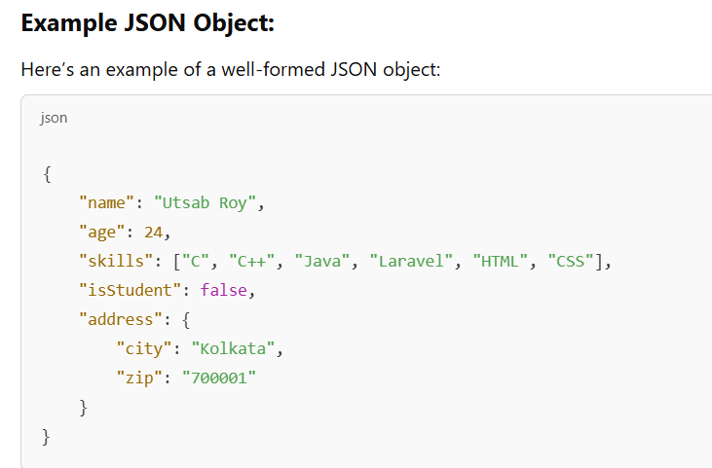

**JSON ENCODE:**

JSON OBJECT FROM ASSOCIATIVE ARRAY(একটা associative array কে JSON Object এ নিব।)

<?php

    $associative_array=["name"=>"utsab","age"=>20];

*//convert associative array to json object*

    $joson_object=json_encode($associative_array);

    echo $joson_object;

?>

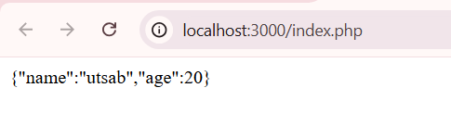

Jsonlint এ গিয়ে validate করতে পারি/চেক করতে পারি json format ঠিক আছে কিনা।

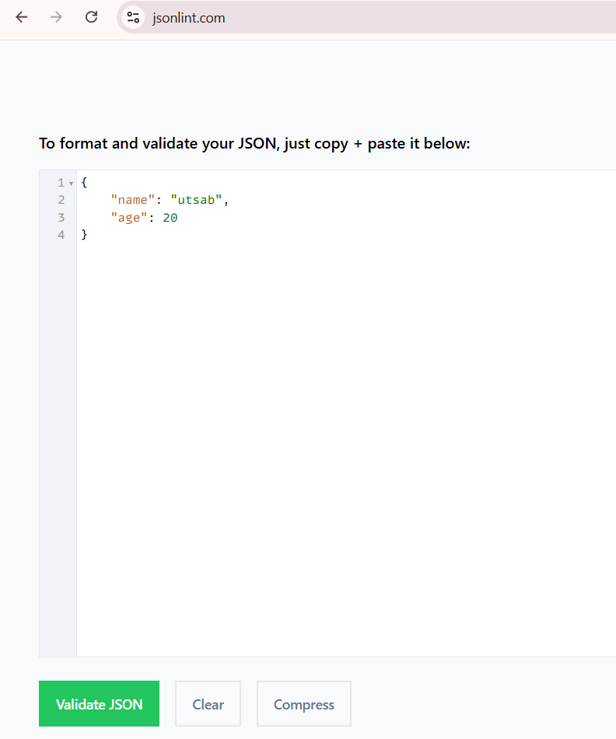

//JSON OBJECT ARRAY

<?php

$phpArray = [

    [

        'id' => 1,

        'name' => 'Alice',

        'email' => 'alice@example.com',

    ],

    [

        'id' => 2,

        'name' => 'Bob',

        'email' => 'bob@example.com',

    ],

    [

        'id' => 3,

        'name' => 'Charlie',

        'email' => 'charlie@example.com',

    ],

];

    $json_object_array=json_encode($phpArray,JSON_PRETTY_PRINT);

    echo $json_object_array;

?>

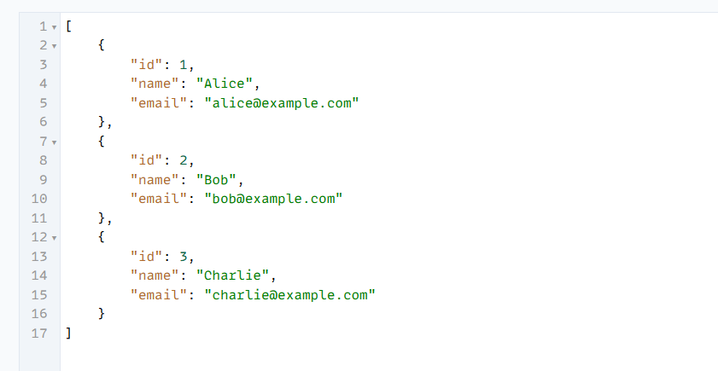

**JSON Decode: JSON Object কে Associative Array তে নিবে:**

Use the json_decode() function with the second parameter set to true to decode a JSON object into an associative array.

If the second parameter of json_decode() is set to false (or omitted), it will return a PHP object instead of an associative array.(TRUE না করলে PHP OBJECT পাব।)

<?php

*// JSON object*

    $jsonObject = '{"name":"Utsab","role":"Assistant Computer Programmer","location":"DUET"}';

*// Convert to associative array*

    $assocArray = json_decode($jsonObject, true);

*// Output associative array*

    print_r($assocArray);

?>

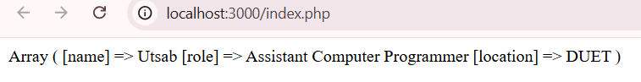

**GET PUT DELETE UPDATE PATCH  
GET REQUEST :  
 Browsers and most tools make GET requests by default when you enter a URL into the address bar or click a link.  
 (মূলত আমরা url এ হিট করলে get request কল হয়।)**

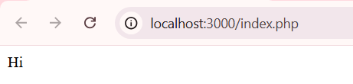

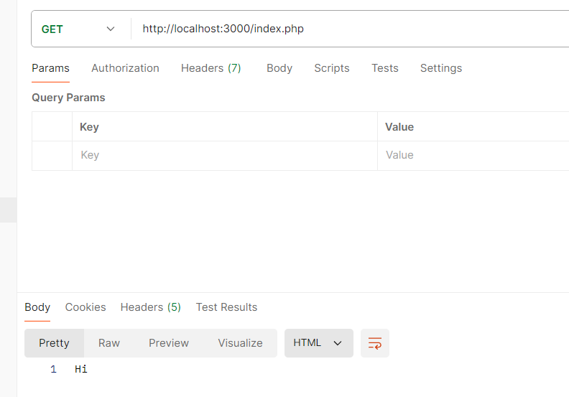

এখানে <http://localhost:3000/index.php> এ হিট করলে $_SERVER['REQUEST_METHOD'] এ GET Request যাবে |

<?php

     if($_SERVER['REQUEST_METHOD']=='GET'){

        echo"GET METHOD CALLED";

     }

?>



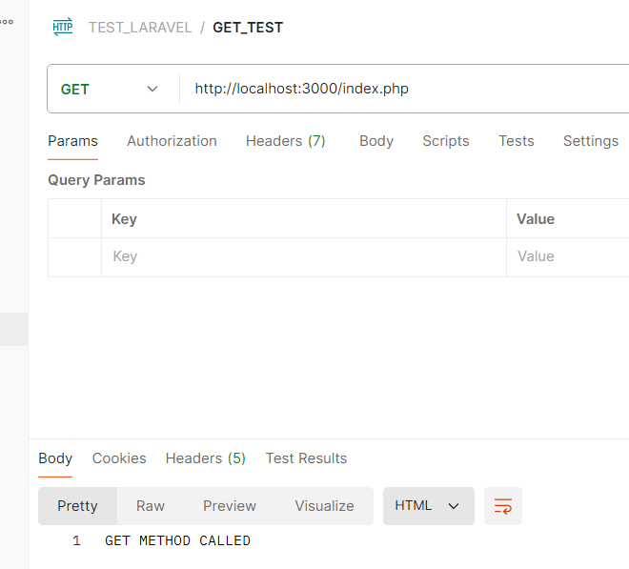

**PUT DELETE UPDATE PATCH:**

<?php

     if($_SERVER['REQUEST_METHOD']=='GET'){

        echo"GET METHOD CALLED";

     }

     if($_SERVER['REQUEST_METHOD']=='POST'){

        echo "POST METHOD CALLED";

     }

     if($_SERVER['REQUEST_METHOD']=='DELETE'){

        echo "DELETE METHOD CALLED";

     }

?>

যে request দিব সেই কনডিশন TRUE হবে এবং আউটপুট দেখাবে।এখানে DELETE requests পাঠানো হয়েছে।

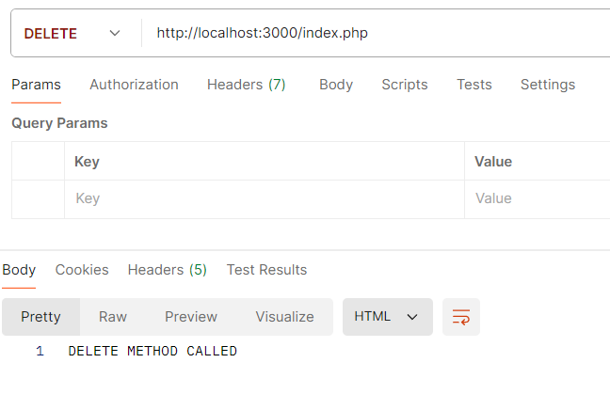

এখানে POSTMAN কাজ করছে Front End হিসেবে (HTML এর FORM এর মাধ্যমে ডাটা পাঠাতে পারি যা POSTMAN দিয়ে করতেছি)এবং PHP কাজ করছে BackEnd হিসেবে(ডাটা প্রসেস করতেছে)।

**JSON ডাটা পাঠাব SERVER এ এবং PHP সেটাকে প্রসেস করবে ও আউটপুট দেখাবে:**

1.JSON data send using post request

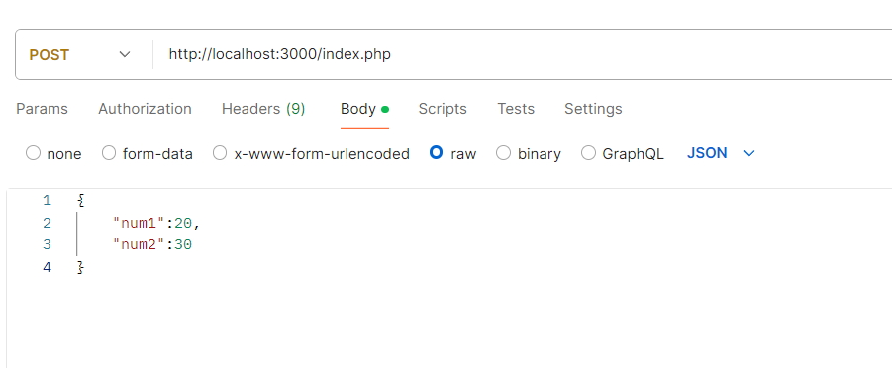

2.recive the data and process the data and show the data

<?php

    if ($_SERVER['REQUEST_METHOD'] == 'POST') {

*// Read raw input json data*

        $rawData = file_get_contents('php://input');

*// Decode JSON data into a Object*

        $show_data = json_decode($rawData);

        echo "$show_data";

    }

?>

OUTPUT:

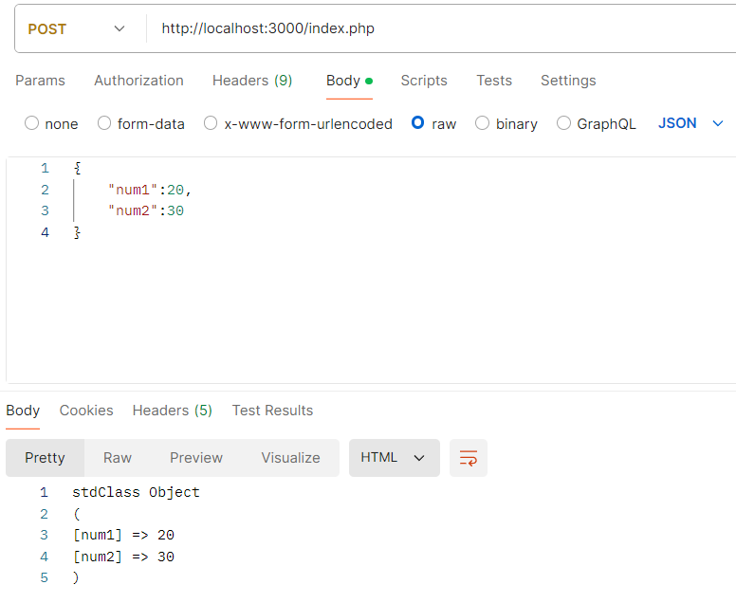

Another Example send json data and recive & process and print processed json data.

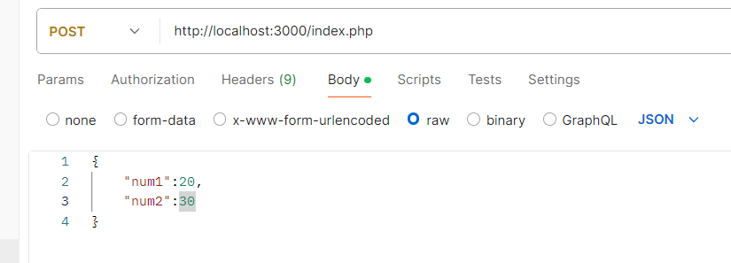

<?php

    if ($_SERVER['REQUEST_METHOD'] == 'POST') {

*// Read raw input data*

        $rawData = file_get_contents('php://input');

*// Decode JSON data into a PHP associative array*

        $show_data = json_decode($rawData,true);

//From associative array we get those data

        $sum=$show_data['num1']+$show_data['num2'];

        $sub=$show_data['num1']-$show_data['num2'];

        $mul=$show_data['num1']*$show_data['num2'];

        $div=$show_data['num1']/$show_data['num2'];

        $associative_array=["sum"=>$sum,"sub"=>$sub,"mul"=>$mul,"div"=>$div];

        $JSON_OBJECT=json_encode($associative_array);

        echo $JSON_OBJECT;

    }

?>

